Data cleaning and preparation:

For an accurate visualisation of the questions, the untidy dataset needs to be cleaned and prepared. The following adjustments were made throughout the cleaning process, for which we used the Tableau Prep tool:

* Removed filed - “company” as it had 93% NULL values.
* Renamed filed - 13% Agent filed value had NULL values, so replaced it with mean value.
* Removed two records where we had special characters (hotel – Re$0rt hotel and C!TY hotel)
* Removed null values from below fields that has NULL values:

      Arrival date month, country, meal, arrival date year

* Created a calculated fields:

1.Total_duration = stays_in_weekend_nights+ stays_in_week_nights

2.Revenue = adr* Total_duration (Revenue indicates total

revenue as per reserved date)

* Combined both datasets (CleanedOutput2.cvs and CleanedOutput.cvs) using the ‘Join’ function.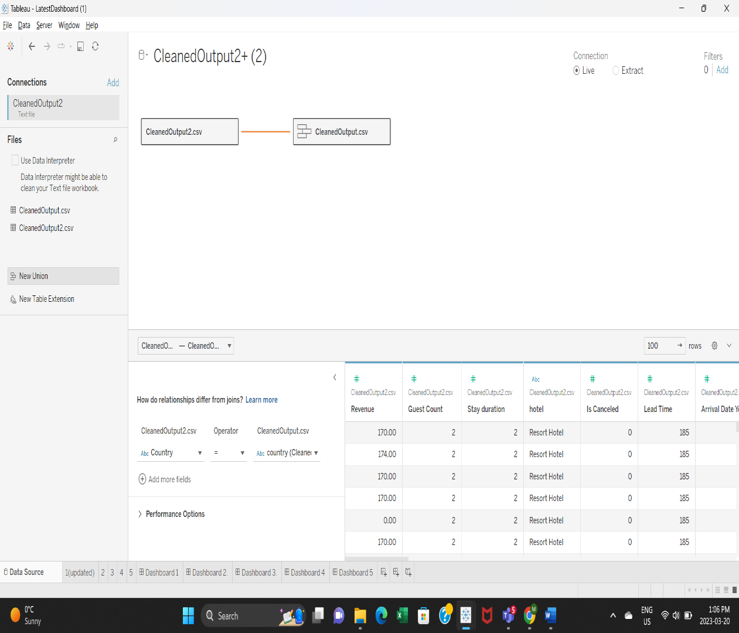

KEY QUESTIONS:

* Which hotel is generating more revenue? **(Revenue-based Analysis)**
* What are the elements that influence the hotel revenue? **(Analysis Using the elements as a basis)**
* How car parking lots impact in generating the revenue? **(Analysis of factors that affect how much money is made out of it)**
* What is the average waiting time for city hotel and resort hotel? **(Analysis of Average waiting time)**
* Which hotel is the top choice among the countries? **( demographical** **Analysis of preferred visitors)**